

MuleSoft PS

(Configured for CeG)

Product Support Reference



Version : V0.2

**Document Control**

|  |  |
| --- | --- |
| **Document Information** | |
| *Document Name* | *MuleSoft PS : Product Support Documentation for MuleSoft @ CeG* |
| *Client* | *Department of e-Governance, Government of Karnataka* |
| *Document Author(s)* | *Prashanth Nuggehalli Chandrashekar* |
| *Document Version* | *V0.2* |
| *Document Status* | *Ready for Review* |
| *Date Last Update* | *12th Jul 2021* |
| *Date Released* | *12th Jul 2021* |

**Document Edit History**

|  |  |  |  |
| --- | --- | --- | --- |
| **Version** | **Date** | **Additions/Modifications** | **Prepared / Revised by** |
| V0.1 | *25th Jun 2021* | Initial Draft | Prashanth Chandrashekar |
| V0.2 | *12th Jul 2021* | Documented Support Center Details after checking with Mulesoft Doc Portal, and included the new screenshot | Prashanth Chandrashekar |
|  |  |  |  |
|  |  |  |  |

**Document Review/Approval History**

|  |  |  |  |  |
| --- | --- | --- | --- | --- |
| **#** | **Name**  ***(Prepared By)*** | **Organization/Title**  ***(Approved By)*** | **Date**  ***(Approval Date)*** | **Comments**  ***(Description)*** |
|  |  |  |  |  |
|  |  |  |  |  |
|  |  |  |  |  |
|  |  |  |  |  |

*This page is intentionally left blank*

**Table of Contents**

**Introduction** **6**

**Overview** **6**

Support Operational Process 6

Steps to Login to Support Center 7

**Reference** **15**

External Links 15

# Introduction

## Overview

This document will provide you to explore steps to login to Anypoint portal and create MuleSoft Product Support Tickets. The links are provided in the reference sections and the reader is advised to refer then for more detailed information.

## *Support Operational Proces*s

This article outlines a basic operational practice that MuleSoft recommends customers follow when troubleshooting an operational incident. It is expected that customers supplement this process with their own organizational continuous improvement processes.

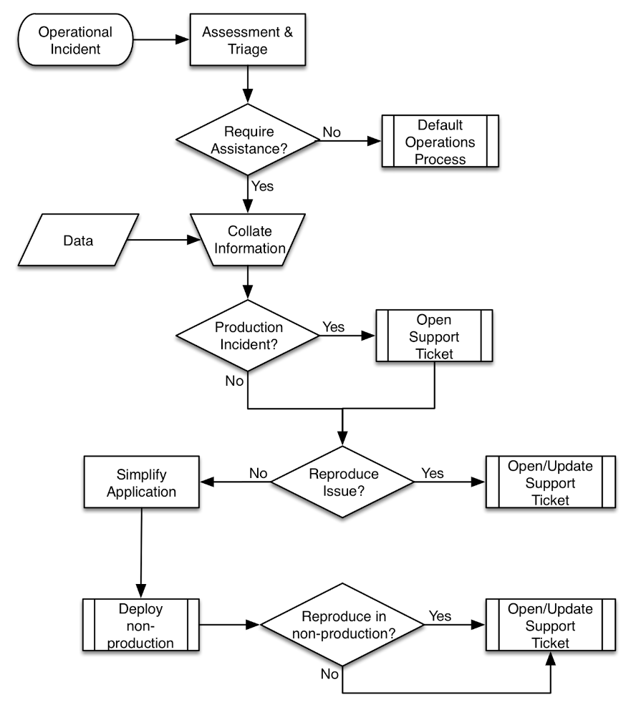

## Steps to Login to Support Center

Login to AnyPoint Portal

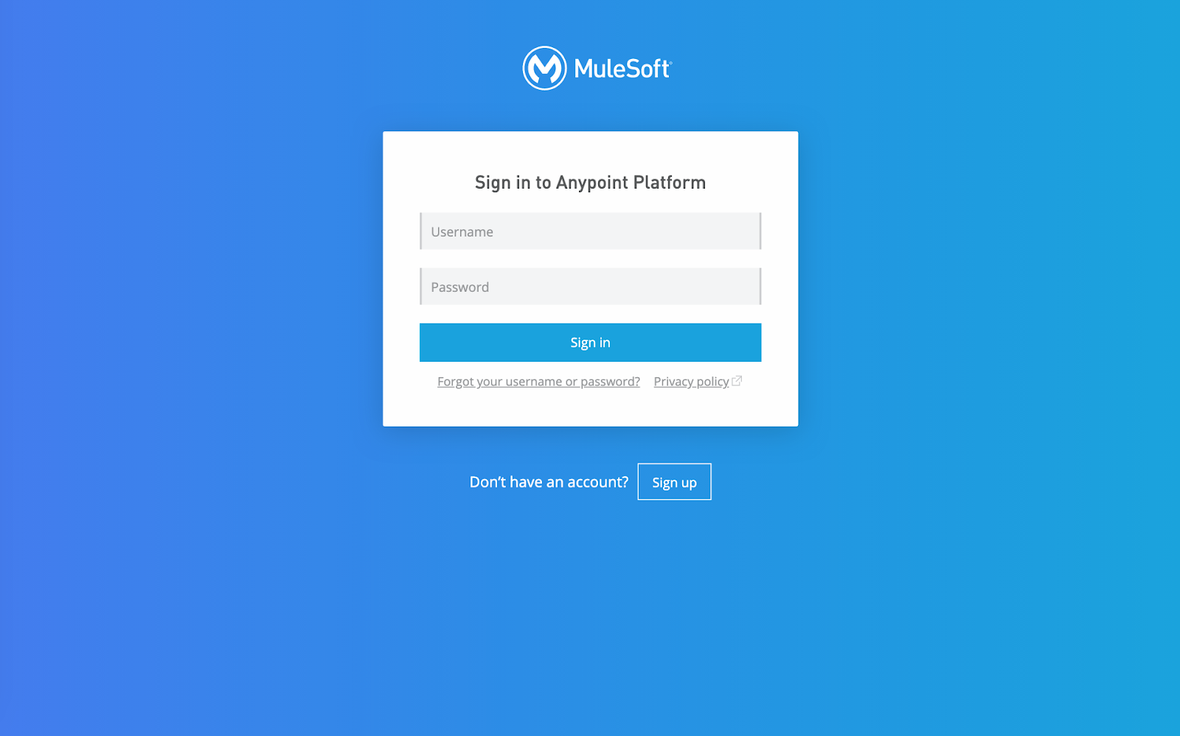

**Link** : <https://anypoint.mulesoft.com/login/>

**Username** : gok-esb-admin

**Password** : Ce**********

Landing Page

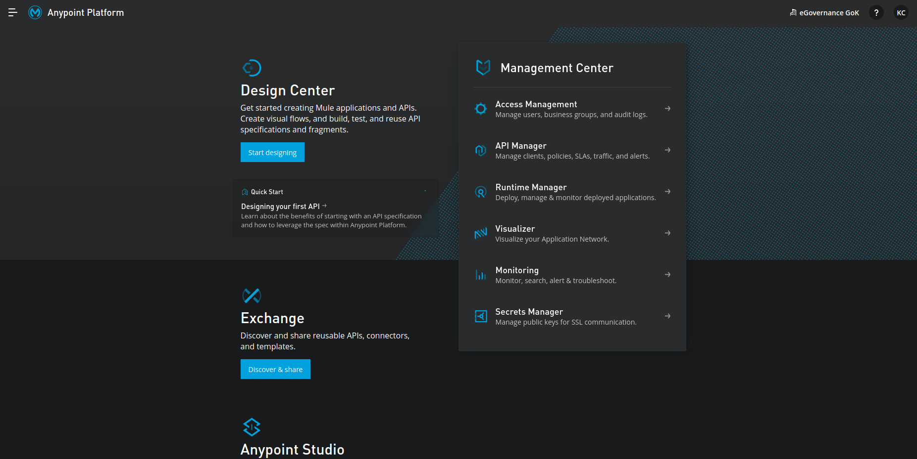

Navigate to DropDown Menu

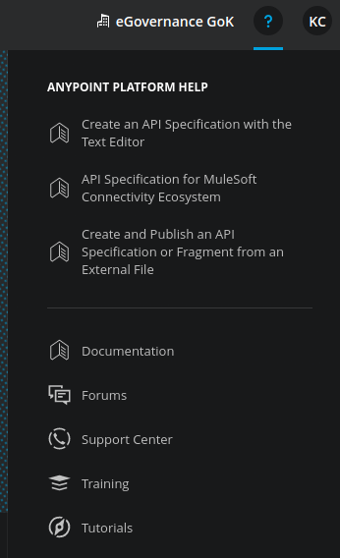

SSO to Support Portal

1. Click on Support Portal
2. Click on Login

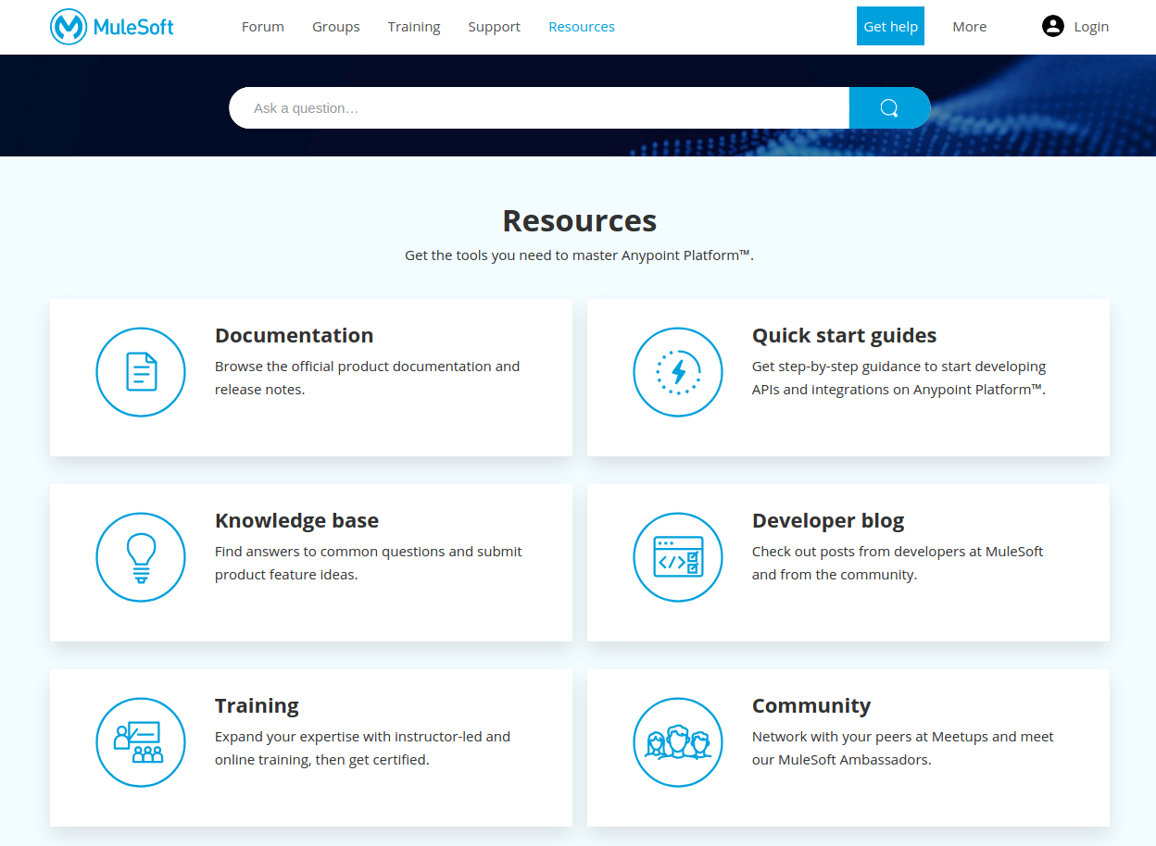

Select Cloud

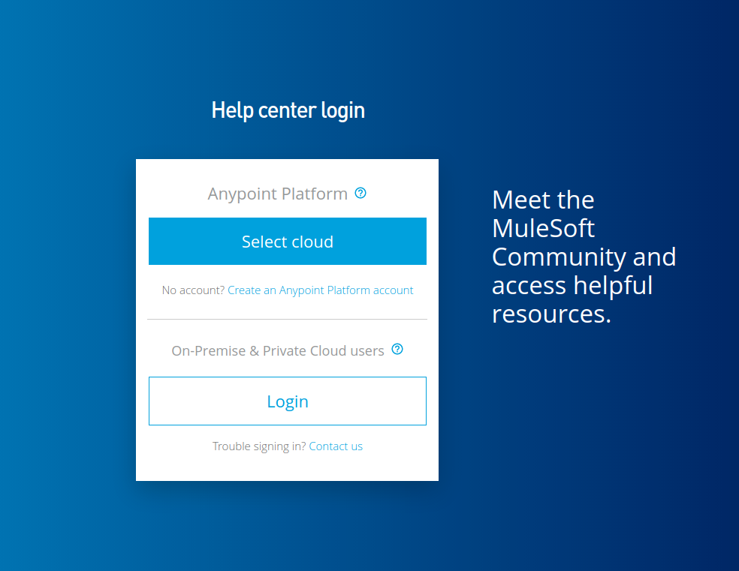

Choose Anypoint Platform

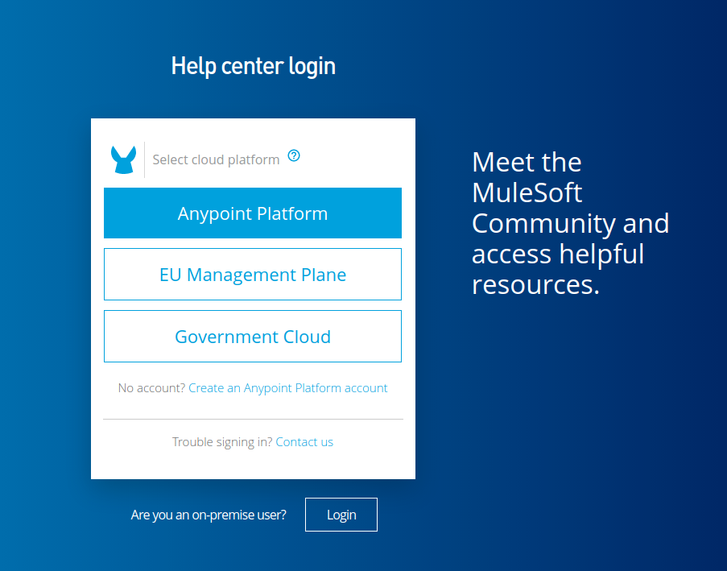

You should see unique id of yours

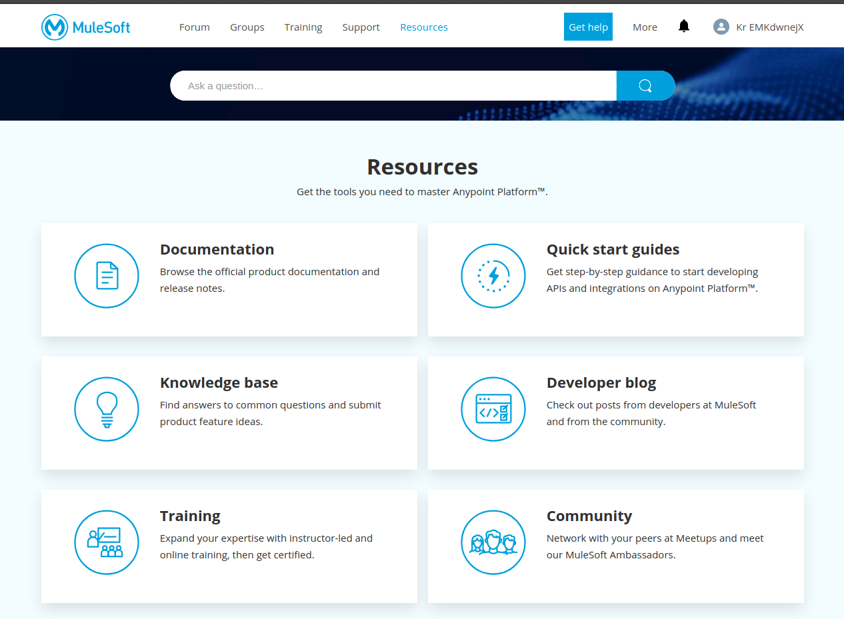

Choose Support from the header menu

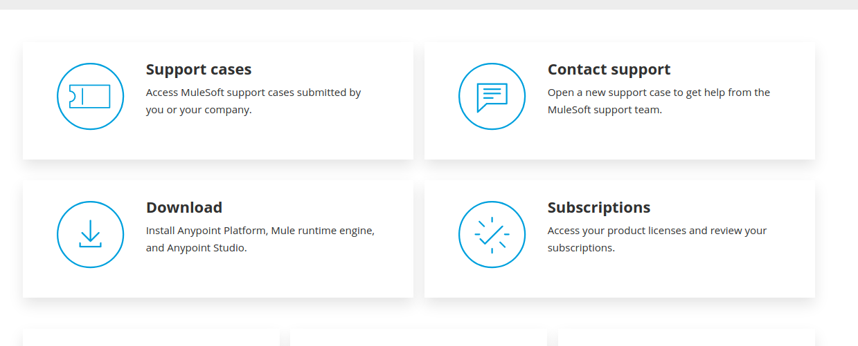

Click on Contact Support

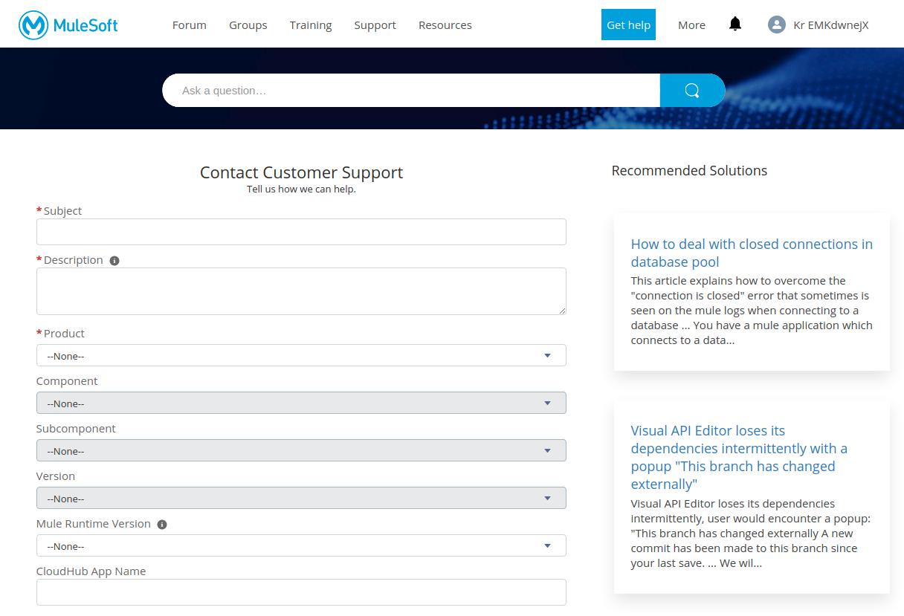

# Reference

## External Links

* <https://help.mulesoft.com/s/article/MuleSoft-Recommended-Support-Process>
* <https://help.mulesoft.com/s/article/How-to-log-a-new-support-case>
* <https://www.mulesoft.com/legal/support-maintenance-terms>
* <https://training.mulesoft.com/course-catalog?results=true&courseFormat=Self-paced>